Official league roster - Basketball
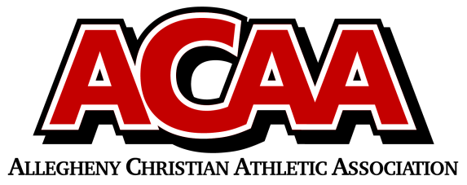

School Name: CACS
Team Colors: Black, White, Red
Overall Wins ___ Losses ____ Ties ___
ACAA Wins ___ Losses ____ Ties ___ OPPONENT: __________________________
Date: _________
Number | Name | Year | Position | Height | Homeschool
4 | Emily McTavish | 12 | C | 5’ 6’’
15 | Calli Manno | 12 | G | 5’ 5’’
0 | Susan Mann | 12 | F | 5’ 7’’
33 | Kaija Ramkawsky | 11 | F | 5’ 7’’
14 | Hannah Finney | 11 | F | 5’ 10’’
22 | Alyson Bloom | 10 | F | 5’ 6’’
44 | Khloe McGarry | 10 | G | 5’ 5’’
23 | Lena Stone | 10 | F | 5’ 7’’
42 | Myra Ramkawsky | 7 | F | 5’ 4’’
51 | Lily Mann | 7 | F | 5’ 5’’
1 | Nadia Sabatino | 6 | F | 5’ 2”
5 | Adi Manno | 6 | G | 5’ 0”
43 | Solara Lopez | 6 | G | 5’ 1”
41 | Maya Joseph | 6 | C | 5’ 5”
35 | Anastasia Thompson | 6 | G | 5’ 3”

Head Coach: Denise Smeal
Asst. coach: Jeff Aldridge
Asst. coach:

Official ACAA League Team Roster. to be submitted to the scorer’s table before each game.

